Artem,

I feel that we could further improve on correlating the Luxand dots with your green dots.

If you are willing to tackle these, I can award an extra $100 for improving these two areas.

First and foremost:

1. I think that you may have picked up the wrong dot initially (dot 1-under the nose), instead of (dot 2-nose tip). I think it is clear that needs to be fixed.

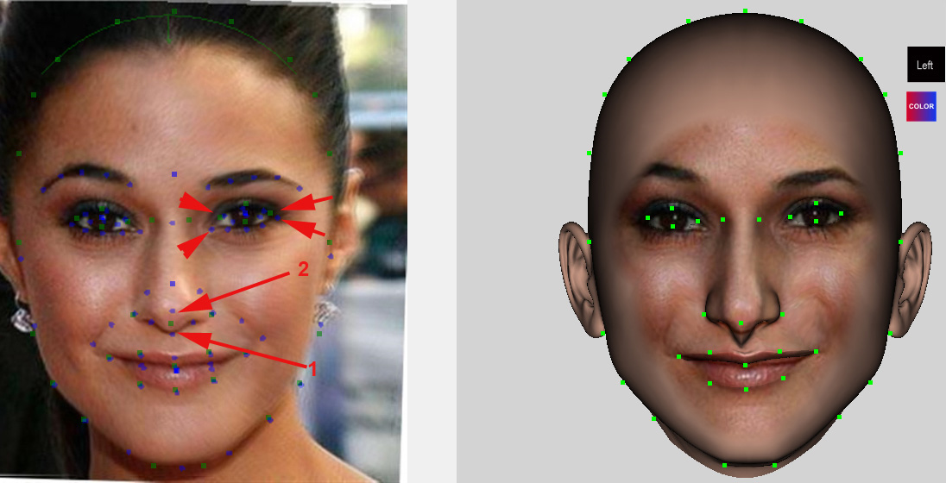

1. There are also imprecisions regarding the eye dots. You correlate one dot (middle of eye) but due to different eye-shapes it may be better to correlate the other 4 dots too.